FRENKEL DEFECTS III

A traveling screening series of contemporary experimental 16mm films

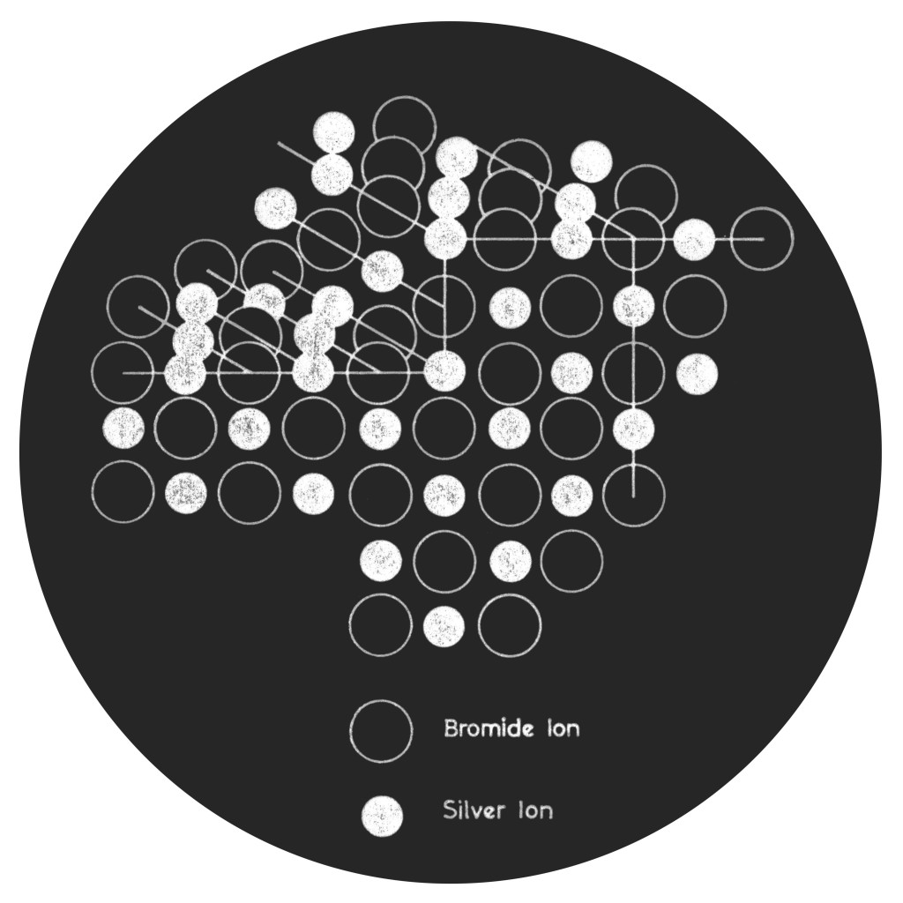

# Overview

Colorado-based nonprofit organization, Process Reversal, presents the third installment of its unique traveling film series -- Frenkel Defects.

This recurring series aims to explore what it means to work in -- and exhibit on -- photochemical film today by examining works from artists operating specifically in this practice. Often, this involves getting their hands dirty at every stage of the process: from optical effects to photo-processing, editing and contact printing, optical sound recording, and even the creation of the photosensitive emulsion itself... As a result (and as suggested by the series' title), creative aberrations make their way into the standard photochemical process, giving birth to a new, textural aesthetic that plays out on the surface of the film strip. More than ever before, film reminds us of its physicality, giving a new sense to Andrei Tarkovsky’s idea of “sculpting in time.”

For this year’s edition, two 70-minute programs of rare and diverse works, nearly all of which originate outside North America, will be presented in their intended 16mm format. Almost all of these films were produced with the help of “artist-run film labs” -- collectively-run organizations dedicated to facilitating artists’ working in photochemical film -- including LaborBerlin (Berlin), L’Abominable (Paris) and Filmwerkplaats (Rotterdam). While these and other organizations have been active in Europe for almost two decades, the trend is just beginning to emerge in North America, with experimental laboratories springing up in Boston, Oakland, Denver, New York, Vancouver, Montreal and elsewhere. Process Reversal, having secured abundant donations of lab equipment, hopes to continue assisting in the growth of these spaces by providing communities with the critical tools, knowledge and resources necessary to ensure the viability of the medium for all.

Additionally, in support of the tour, Process Reversal member Kevin Rice will facilitate workshops on “Emulsion Making & Coating for Motion Picture Film” at select locations.

# Program Details

This year’s edition of Frenkel Defects features two separate programs, each approx. 75 minutes long. While both programs may not be shown at each tour stop due to time constraints, we will be doing our best to ensure a fair representation of all the works, whether that means showing both programs in one night, cycling the programs from venue to venue, or showing each program on separate dates.

Film selection and programming by Mariya Nikiforova (Balagan Films) and Kevin Rice (Process Reversal)...

## Program 1

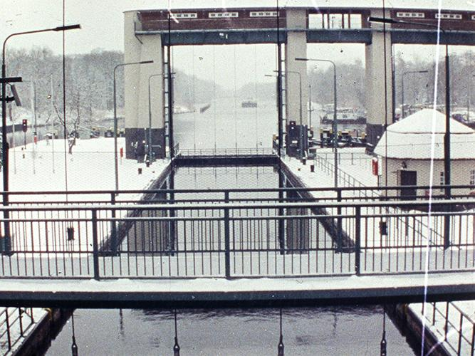

**Schleusenroth | Volga (504 feet, 1.33:1, Wild Sound, Germany/Lebanon)**

“Looking at river locks.”

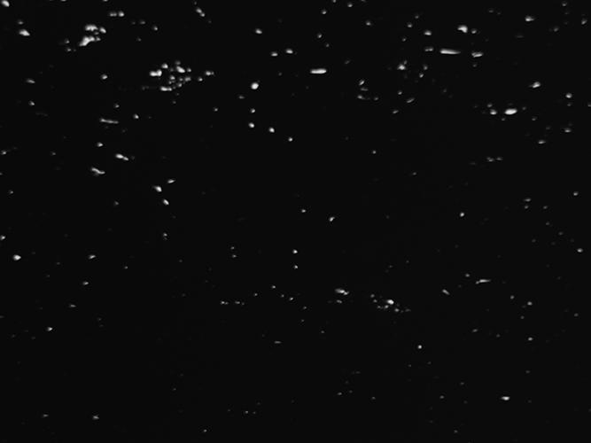

**Flow | Lichun Tseng (612 feet, 1.33:1, Optical Sound, Netherlands)**

“Change is a process, is the starting point equal to the end point? What if everything is in a flow, what meaning of value of life can be derived from the interconnectedness of all things? Reflecting the subtle relationships between the flow of changing, awareness of being and observation of breathing through abstract and rhythmic moving images. Integrating and developing a poetic state of contemplative and meditative process and flow in between void and solid; moving and still; expanding and gathering; strength and softness.”

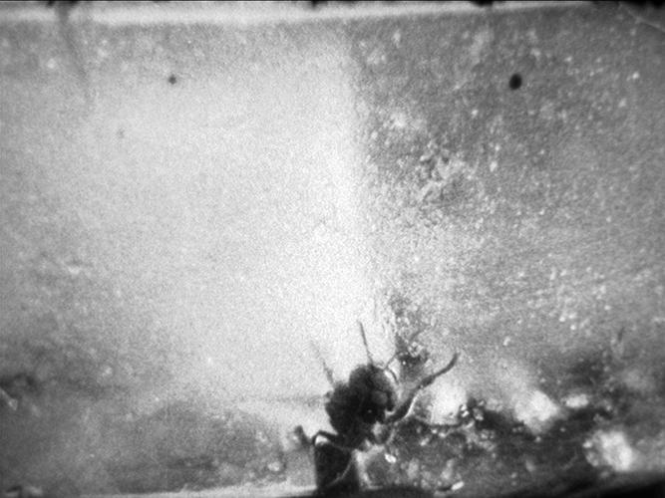

**Fractions | Guillaume Mazloum (1620 feet, 1.33:1, Optical Sound, France)**

“Fractions is a seven part film. Seven sequences, each with a pattern and a reference to a text of a political nature, to create a space for reflection on the scope and responsibility of these images. Between self-portrait and testimony, each fraction is an autonomous thinking, remaining yet necessary to the overall restitution of a personal research on film practice, in correlation with the emancipatory thinking. The images then become a pretext for this reflection, freed from their narrative and documentary nature, the site of a more intimate experience. This work draws the accomplishment of several years of reading, strewed with fleeting moments of reality captured instinctively with my camera, all reworked and remodeled with traditional cinema tools.”

## 

## Program 2

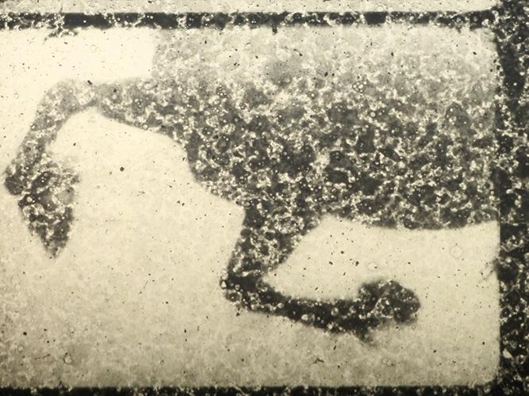

**Konrad & Kurfurst | Esther Urlus (252 feet, 1.33:1, Optical Sound, Netherlands)**

“A fictional re-enactment of a 5 minutes happening that took place during the Olympic games in Berlin 1936. Made on home brew emulsion and color toned with the helping hand of technical publications from early cinema and photographic experiments. The home brew emulsion as fragile metaphor for the heroism of Konrad and his horse Kurfurst. Falling from his horse he became a national hero but overtaken by history, an anti-hero.”

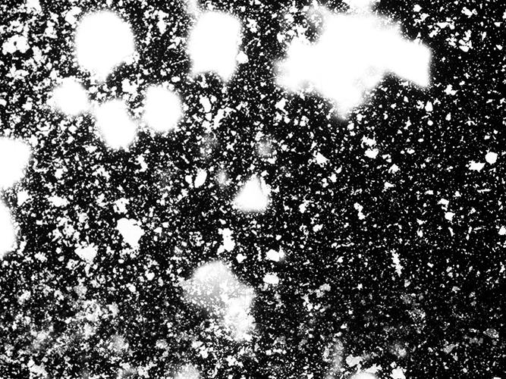

**WAKE | Eric Stewart (288 feet, 1.33:1, MOS, USA)**

“*Wake* is a dirge in celluloid. It is a celebration of my father's life, a meditation on his body and a visual record of mourning. When my father died, there was never a chance to see his body after life had left it. This film was made by placing his ashes directly on 35mm film in a dark room and moving the film a frame at a time. What we see in this process of photograming is not the object in the photographic sense, but instead a representation of the space surrounding an object. The photogram is a shadow charting the distance between things.”

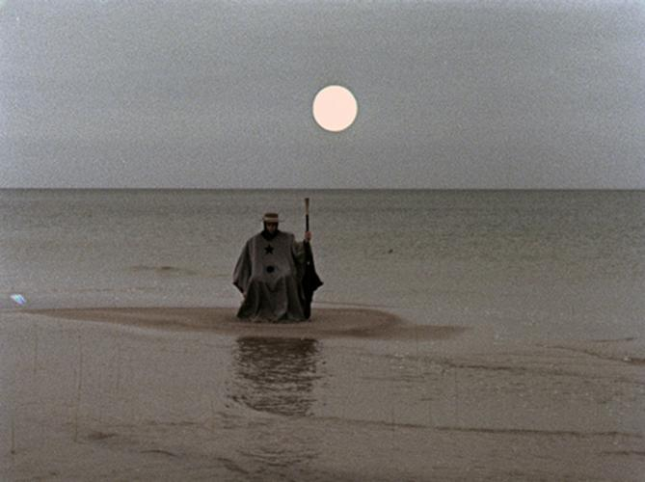

**In the Traveler’s Heart | DISTRUKTUR (720 feet, 1.33:1, Optical Sound, Lithuania/Germany/Brazil)**

“The winter reigns as the Traveler crosses by feet an ancient landscape.

In this place there's also another presence, someone who's very similar to the Traveler. Does the Traveler realise this figure that cohabits the same space as him? Is the other a guardian angel or a devil?”

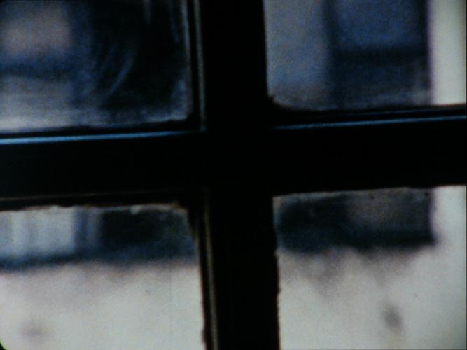

**Aula Magna | Andrés Denegri (360 feet, 1.33:1, Optical Sound, Argentina)**

“A structural farewell poem made for a beloved place. The images were shot frame by frame over the course of a year, in order to portray the author’s home main room through the variation of the light coming from a window. The sound, by Pablo Denegri, was made by mixing and processing, in real time, direct recordings made in the same space.”

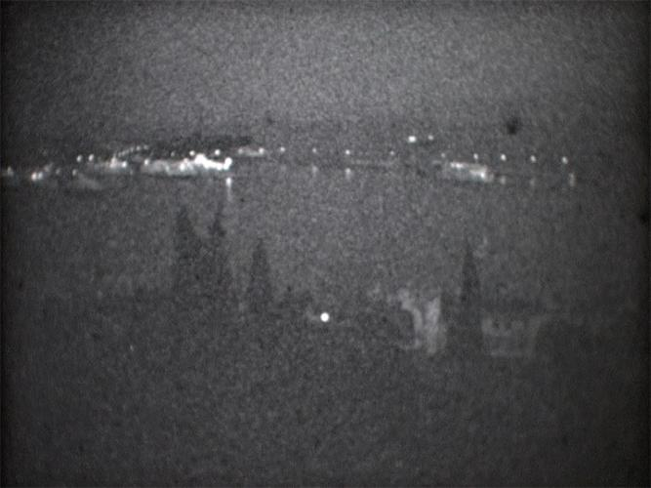

**Split Film 100110 | Dražen Zanchi (1080 feet, 1.33:1, Wild Sound, Croatia/France)**

“Boats are entering in the Split harbor. Each sequence is a maneuver: slow and continuous. Nevertheless, boats and their movements become more and more difficult to recognize because the image is drawn in fluctuations of its physical elements. Textures of bulky light layers and grainy grey noises are confounded with the soundtrack. The latter is articulated around the touch, i.e. local and non-propagating formations grafted on thick resonant and tonal substrate.”

*Notes on Film Length: There are 40 frames per foot of 16mm film, with “sound speed” projection being carried out at a rate of 24 frames per second. Thus, for every foot of film projected, there is (in theory at least) 1.66 seconds of projection time, or 1 minute of projection for every 36 feet of film.*

*Notes on Audio Format: ‘Optical Sound’ indicates a print that has had a waveform pattern printed into the soundtrack area of the filmstrip (i.e. a married print) which is then read and amplified by the projector during projection. ‘Wild Sound,’ on the other hand, indicates a print whose audio is not married to the print and must instead be played back through an independent system. Finally, MOS indicates a film that is silent, but projected at sound speed (24 fps) whereas ‘Silent’ indicates a print that is both silent and projected at silent speed (18 fps).*

# 

# Filmmaker Biographies (in alphabetical order)

**Andrés Denegri**

Andrés Denegri (Buenos Aires, 1975) is a visual artist who works mostly on film, video, photography and installations. His work has been featured at numerous exhibitions and festivals, where he has achieved significant recognitions: Grand Prix at the Salón Nacional de Artes Visuales (Buenos Aires, 2015), First Prize of Itaú Cultural 2013 (Buenos Aires, 2013), Golden Medal for the Best Experimental Film at Belgrade Documentary and Short Film Festival (Serbia, 2012), Grand Prix of MAMBA and Fundación Telefonica Prize for Arts and New Technologies (Buenos Aires, 2009), Best National Short Film at Mar del Plata International Film Festival (Mar del Plata, 2008), Juan Downey Prize at the Bienal de Video y Nuevos Medios de Santiago (Chile, 2007), Golden Impakt Award (Utrecht, 2005), 25 FPS Prize (Zagreb, 2005) among others. He is co-director of the Bienal de la Imagen en Movimiento and curator of the film and video program at the Museum of Modern Art of Buenos Aires. He is professor at the Universidad Nacional de Tres de Febrero and Universidad del Cine. Denegri currently lives and works in Buenos Aires.

* * *

**DISTRUKTUR**

Melissa Dullius and Gustavo Jahn are Brazilian artists and filmmakers. Since 2007 they form the duo DISTRUKTUR.

Films, photographs, installations and performances form Distruktur's body of work.

Films by Distruktur have been presented in festivals such as Berlinale, Torino, Moscow IFF and Curta Cinema in Rio de Janeiro, as well as in New Museum in New York, Paço das Artes in São Paulo, and Vilnius Contemporary Art Centre.

Current projects include the film-performance NAVIGATION, the work-in-progress FILME DE PEDRA and their first feature film, in post-production phase. The duo lives and works in Berlin.

[distruktur.com](http://www.distruktur.com/)

* * *

**Dražen Zanchi**

Dražen Zanchi, born in 1968 in Split, Croatia, PhD in theoretical physics, is associate professor at Paris Diderot University , film-maker and performer.

His most representative scientific works focus on the organoleptic perceptions of the astringency and ageing of red wines, in relation with the sensation of granularity and dustiness upon tasting (e.g. J. Phys. Cond. Mat. 2008). Also to cite is his 16 mm 30’ film Mercedes Dunavska or the Impossible Trajectory A1 (2008), articulated around dark, weakly exposed and then blown up coarse-grained visual and, in certain points, sound materials. So here’s the Grain Man.

[zanchinet.wordpress.com](https://zanchinet.wordpress.com/), [lightcone.org/en/filmmaker-1115-drazen-zanchi](http://lightcone.org/en/filmmaker-1115-drazen-zanchi) & [dailymotion.com/draegue-zanunch](http://www.dailymotion.com/draegue-zanunch)

* * *

**Eric Stewart**

Eric Stewart (b. 1985; Chicago, Illinois) is an interdisciplinary multimedia artist and educator. Working predominantly with 16mm film his artistic practice invokes photochemical and darkroom processes to investigate landscape, place and cultural identity in the American West. Before moving to Colorado in 2013, Eric lived in the San Francisco Bay Area where he taught a biweekly analogue filmmaking workshop called “The Elements of Image Making”. His 16mm films and installations have exhibited at: The Yerba Buena Center for Fine Arts (SF), Yale University, Crossroads Film Festival (SF Cinematheque), The Portland Experimental Film Festival and The Florida Experimental Film Festival. His current project examines history of the terrarium, through time lapse photography and DIY horticulture.

**Esther Urlus**

Esther Urlus is a Rotterdam-based artist working with motion picture film formats Super8, 16mm and 35mm. Resulting in films, performances and installations, her works always arise from DIY methods. Kneading the material, by trial, error and (re) inventing, she creates new work. Urlus is the founder of WORM Filmwerkplaats, an artist-run workspace dedicated to motion picture film as an artistic, expressive medium. Her work has been exhibited and screened at film festivals worldwide, among other 25FPS festival Zagreb, Ann Arbor Film Fest, Oberhausen Short Film Festival, Sonic Acts, and the International Film Festival Rotterdam.

[estherurlus.hotglue.me](http://estherurlus.hotglue.me/)

* * *

**Guillaume Mazloum**

Guillaume Mazloum is a French director and screenwriter. His filmography includes seule (2005), fake (2009), filmer la musique (2009), peine perdue (2010), black babe (2010), sorcières mes soeurs de Camille Ducellier (2010), Birds on Air de Colin Ledoux (2011), un diable sur le tympan (2012), moter (2012), aurore (2013), and Fractions (2015).

* * *

**Lichun Tseng**

Lichun Tseng, 1979, is an artist from Taiwan who has been living and working in the Netherlands since 2007. She works primarily in motion picture film and installation. In her works, she searches for the experience of the vital dimensions of life, absorbing and partaking in it, grasping its wholeness; in which exploration and reflective contemplation are profound mental drives. She is one of the members of Filmwerkplaats, Rotterdam where she develops her films using DIY methods.

[lichuntseng.com](http://lichuntseng.com/)

* * *

**Volga**

The Volga is the longest river in Europe. We are two boatmen sailing it incessantly up and downstream in search of some music, but we know, as every fool does, no one can sail twice on the same waters. That’s why we have no biography. The Volga is a river of no return.

# About the Curators

**Mariya Nikiforova**

Mariya Nikiforova was born in 1986 in Saint Petersburg, Russia. She received a BFA in Visual & Media Arts from the Honors Program at Emerson College in 2009. She is currently pursuing a master's degree in cinema studies at the Sorbonne Nouvelle (Paris III) while continuing to work in 16mm as part of the independent film labs L'Etna and L'Abominable.

**Kevin Rice**

Originating from Denver, Colorado, Kevin Rice is a ‘film archivist’ whose practice focuses on the study of photochemical theories, the development of lab resources for filmmakers, and the documentation of various darkroom odysseys on motion picture film. He has taught and screened work at film communities all around the world, including no.w.here (London), l’abominable (Paris), Klubvizija (Zagreb), Laborberlin (Berlin), Crater Lab (Barcelona), Black Hole Cinema (Oakland), Echo Park Film Center (Los Angeles), LIFT (Toronto), IRIS (Vancouver) and many more. In 2012, he helped co-found *Process Reversal*.

# Current Tour Schedule

Below is the list of currently **confirmed** dates and venues for October. If you would like to host a screening of Frenkel Defects, please write to us at contact@processreversal.org.

## Frenkel Defect Screenings

OCTOBER 6th Detroit, MI with Mothlight Microcinema

OCTOBER 7th London, ON with LOMAA

OCTOBER 8th Toronto, ON with Regional Support Network

OCTOBER 10th Buffalo, NY with Sugar City

OCTOBER 14th Binghamton, NY with Binghamton University

OCTOBER 15th Amherst, MA with Hampshire College

OCTOBER 20th Providence, RI with AS220

OCTOBER 22nd Boston, MA with Balagan Films

OCTOBER 24th Montreal, PQ with Double Negative

OCTOBER 27th Baltimore, ML with Sight Unseen

OCTOBER 29th New York, NY with The Firehouse Space

NOVEMBER 2nd Atlanta, GA with EYEDRUM

NOVEMBER 4th Asheville, NC with Asheville Microcinema

NOVEMBER 5th Durham, NC with UNEXPOSED

NOVEMBER 10th Boulder, CO with Process Reversal

NOVEMBER 11th Denver, CO with Process Reversal

NOVEMBER 14th Los Angeles, CA with Echo Park Film Center

NOVEMBER 17th Oakland, CA with Black Hole Cinematheque

NOVEMBER 18th San Francisco, CA TBA*

NOVEMBER 21st-22nd Portland, OR with Cinema Project

NOVEMBER 24th Seattle, WA TBA*

NOVEMBER 27th - 28th Vancouver, BC with IRIS Collective & Cineworks

DECEMBER 1st Edmonton, AL TBA*

DECEMBER Milwaukee TBA*

DECEMBER Chicago, IL TBA*

Emulsion Workshops

OCTOBER 3rd-4th Detroit, MI with Mothlight Microcinema

OCTOBER 10th Buffalo, NY with Sugar City

OCTOBER 16th Amherst, MA with Hampshire College

OCTOBER 19th-20th Providence, RI with AS220

OCTOBER 26th New York, NY with Pratt University*

NOVEMBER 7th-8th Durham, NC with Duke University

NOVEMBER 20th-21st Portland, OR with NorthWest Film Center*

Other Events

*Introduction to Contact printing, Optical Sound Recording and Color Timing*

NOVEMBER 13th-15th Los Angeles with Echo Park Film Center*

*25th AMIA Conference Panel: Growing a Global Slow Film Movement - Case Study L.A. Filmlab*

NOVEMBER 20th Portland, OR with Echo Park Film Center & USC Film Archives

*Experimental Color Printing & Processing*

NOVEMBER 29th Vancouver, BC with Cineworks

# About Process Reversal



*Process Reversal* is a US based, tax exempt organization & programming collective whose mission and purpose is to advocate and ensure the viability of film for all.

Since 2012, *Process Reversal* has been producing several educational programs oriented towards the promotion of the argentic arts, including travelling workshops and screenings that have visited over 20 countries and 50 discreet film communities around the world. Today, *Process Reversal* continues to operate these programs, but has also expanded into charitable initiatives to help further achieve its purpose. This includes the *Film Labs Program* which aims to supply celluloid oriented communities (especially those in the US) with the necessary resources to build, operate and maintain public facilities for working with and presenting on motion picture film. Among those resources, Process Reversal has been fortunate enough to receive donations of countless pieces of essential equipment -- including projectors, contact printers, optical printers and optical sound camera -- which it plans to distribute to these communities and train them in their maintenance and operation. In addition to this, Process Reversal also focuses on designing and manufacturing new equipment for use in everything from processing to projection.